A dreamy planet in the universe is shining with luxury lilac light in the style of path opulent grand and cyberpunk;cinematic lighting, unreal engine, photorealistic --q 2 --ar 16:9 - Upscaled by

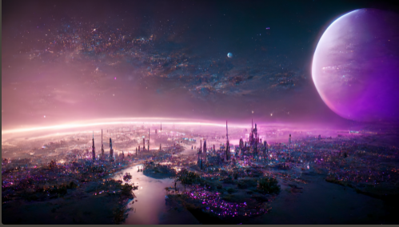

A dreamy planet in the universe is shining with luxury blue light in the style of epic realistic opulent;cinematic lighting, unreal engine, photorealistic --q 2 --ar 16:9

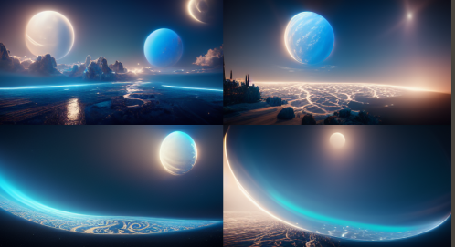

Dreamy planets in different colour which floating in the universe are shining with luxury green light in the style of epic realistic opulent;cinematic lighting, unreal engine, photorealistic --q 2 --ar 16:9

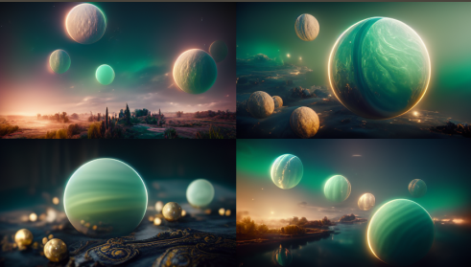

Dreamy planets in different colour which floating in the universe are shining with luxury red light in the style of epic realistic opulent;cinematic lighting, unreal engine, photorealistic --q 2 --ar 16:9

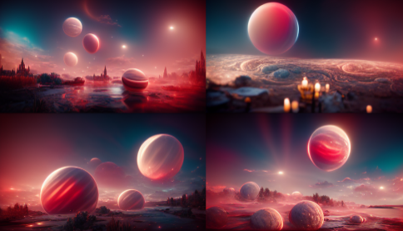

A dreamy planet in the universe is shining with luxury lilac light in the style of epic realistic opulent;cinematic lighting, unreal engine, photorealistic --q 2 --ar 16:9

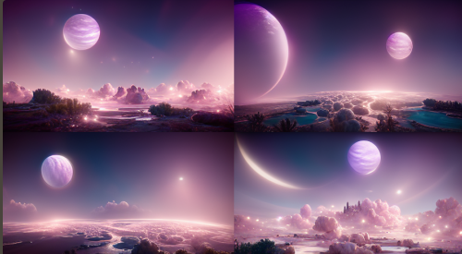

A dreamy planet in the universe is shining with luxury lilac light in the style of epic realistic opulent Marc Simonetti

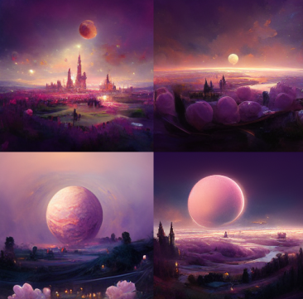

A dreamy planet in the universe is shining with glittery lilac light in the style of epic realistic opulent Marc Simonetti

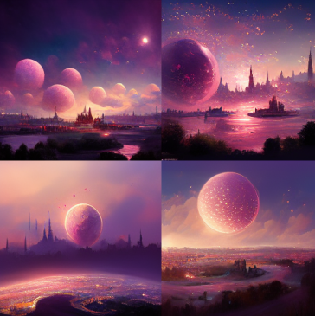

A dreamy planet in the universe is shining with glittery lilac light in the style of epic realistic opulent epic realistic

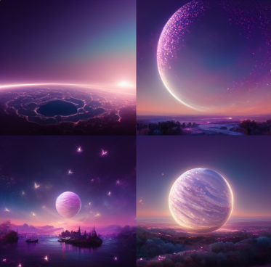

A dreamy planet in the universe is shining with glittery lilac light in the style of epic realistic opulent black background beautifully

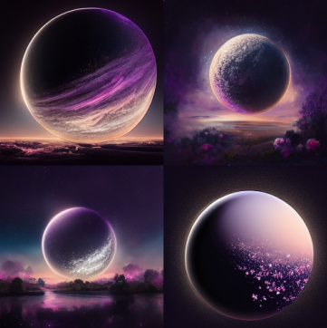

A dreamy planet in the universe is shining with glittery lilac light in the style of epic realistic opulent path opulent grand

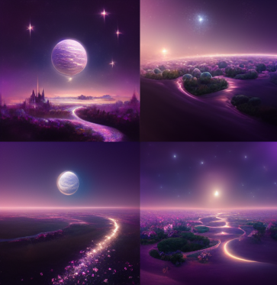

A dreamy planet in the universe is shining with glittery lilac light in the style of epic realistic opulent ultra detailed by

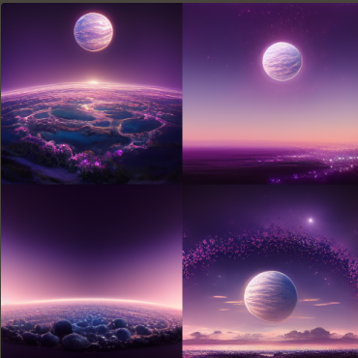

A dreamy planet in the universe is shining with glittery lilac light in the style of epic realistic opulent Detroit: Become Human

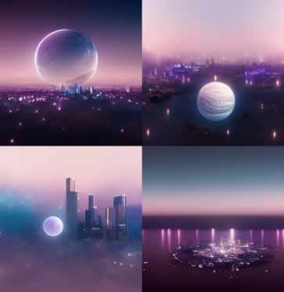

A dreamy planet in the universe is shining with glittery lilac light in the style of epic realistic opulent Cyberpunk 2077

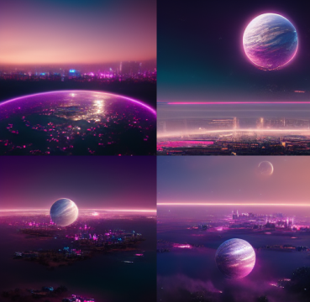

A dreamy planet in the universe is shining with glittery lilac light in the style of epic realistic opulent SCHMOOZE

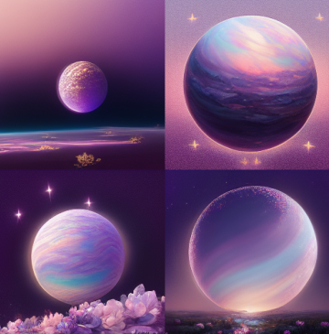

A dreamy planet in the universe is shining with glittery lilac light in the style of epic realistic opulent cyberpunk,V-ray render

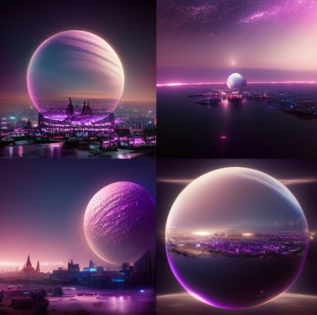

A dreamy planet in the universe is shining with glittery lilac light in the style of epic realistic opulent

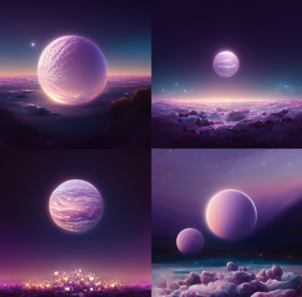

Above the sea of fantasy is a nightclub called "Sugar Metaland". The whole luxury nightclub is flashing with violet neon light in the style of annibale siconolfi.--q 2

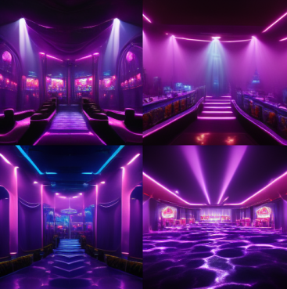

The pale blue sea, azure sky, and white sandy beaches are covered with pink roses, and the main colors of this painting are pale blue and pink. Stars, streamers, fairy tales, many complex details, overall clear and coordinated, ultra-high definition, dream engine, ultra-wide viewing angle, epic rendering, hot search on art stations, 8k --w 1800 --h 3200 --chaos 10 --uplight

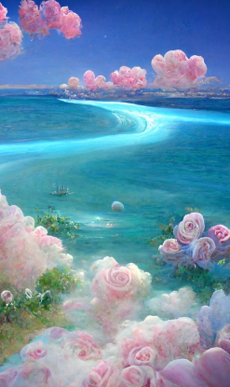

Holy Light White Butterfly Angel, blooming flowers, pastel colors, white, union, flowing, pink, beige, surreal, painting, ethereal, --ar 9:16

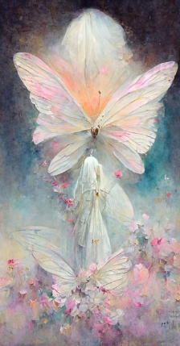

a beautiful and ethereal, opalescent, iridescent, and sparkling pastelpunk peace tree in a magical surreal forest with fireflies HD --ar 9:16

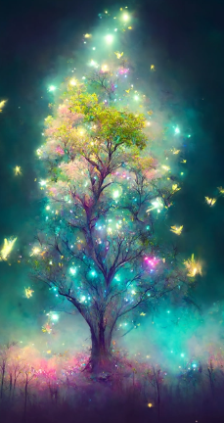

A super cute young dragon, Chinese dragon, Snow Dragon HD --ar 9:16

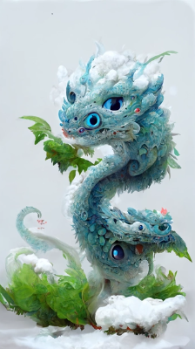

<https://i.mj.run/45227326-9ff0-4364-a9b5-4a022a4d050a/0_3.png> Night, the Milky Way, starlight, The silver-white crescent moon is accompanied by the galactic starlight sprinkled on the beach, Coconut trees on the beach, there are many glowing creatures in the beach, the beach is the shape of love, pebbles, glowing creatures, fluorescent, golden, color, dreamy, super wide-angle light , Unreal Engine, 4K HD, HD, Volumetric light, bioluminescence, Ultra-wide viewing angle, HD --ar 9:16 --uplight

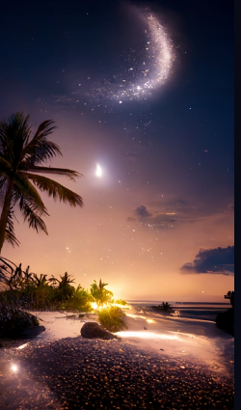

The picture is transparent. A huge silver-white crescent moon is scattered on the beach. The Milky Way shines with many purple-blue roses. There are many purple-blue rose flowers on the beach, fantasy, highly detailed, beautiful, 8k, octane rendering, real photos, complex details, ultra-wide viewing angle, panoramic shooting, and several purple-blue roses in the foreground. Duo

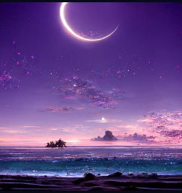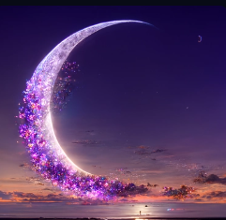

Imagine angel, beautiful, magical, goddess Wu, adventure, mirror, glass, magic circle, magic circle, fantasy, mist, light, crystal, gold, nebula, surreal, illusory angel, beautiful, magical, goddess Wu, in the middle, magical. Mirror, Glass, Magic Circle, Magic Gate, Fantasy, Mist, Fluorescence, Crystal, Black, Nebula, Surreal, unreal engine，HD --ar 9:16

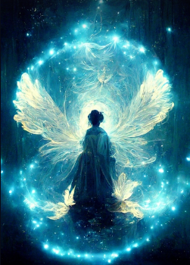

<https://i.mj.run/c8608f00-7cbe-47d0-bd7f-09414beace01/0_1.png> Gorgeous crystal palace,CG rendering European styleoverlooking,fairy tale,rose surround,lighting effect,heavenly,starry sky,super detail,illustration,4K,unreal engine,ethereal cloud,HD --ar 9:16

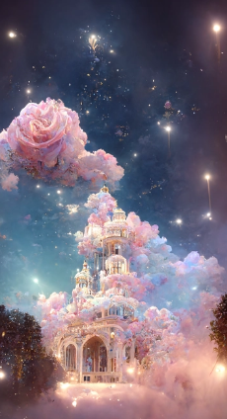

angel, beautiful, stunning, goddess, breathtaking, mirrors, glass, magic circle, magic portal, fantasy, mist, bioluminescence, crystals, gold, nebula, hyper-realistic, unreal engine --ar 9:16

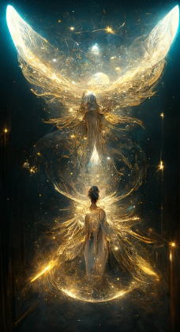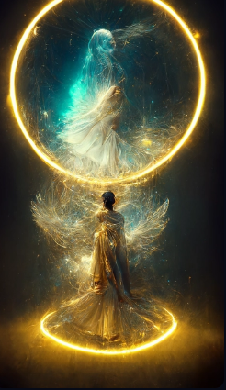

magical Milan Cathedral, heaven, white, light pink, tiffany blue, light pink, glowing water, pink rose, diamond, magic, photorealistic, redshift rendering, CGI , 3D, Ultra Detail, Fine Detail, Photorealistic, 8K, Masterpiece, Feature artstation , Unreal Engine hd --ar 9:16

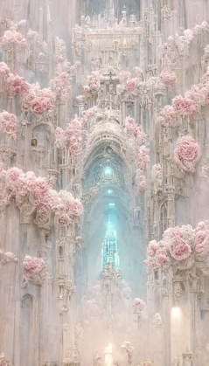

**cool Pixar brown dog , character portrait , Big grin , carrying copious amount of treasure and jewels in satchel falling out on ground , jewels and treasure , golden crown , diamonds , sappires , rubies , high quality offical art by Pixar , golden ratio , cinematic lighting ,8K, upbeta, s 5000 --ar 9:16

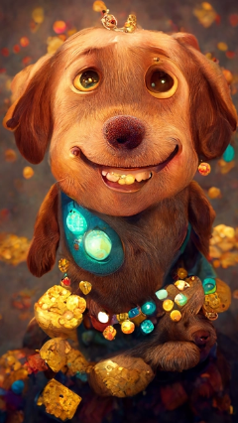

humansight, Gigantic ancient ornamented babylonian city, lush vegetation, Cinematic Lighting, concept art, majestic, --ar 9:16

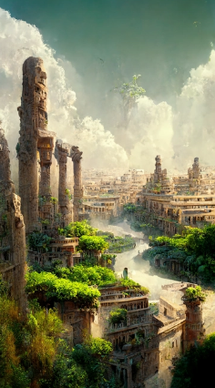

Fox photos in flowering gardens, Fox professional portfolio, trends in art station, super detailed, everything in a beautiful light, stylish design background, fantasy art, Photoshop 8khd --ar 9:16

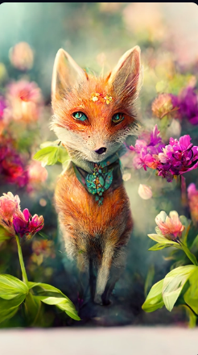

The purity of the sky, the deep purple of the Milky Way, was breathtaking. Depression, emptiness, beach, fluorescence, reflection. 8K, Ultra wide Angle, panoramic, 3D, Ultra HD, High pixel, Marc Adamus HD Landscape Photography --ar 9:16

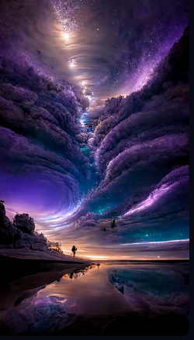

Tiny cute adorable white kitten, in a 1970s disco, anthropomorphic, Jean-Baptiste Monge, soft cinematic lighting, 8k, intricate details, portrait, Pixar style character, old fashioned movie style

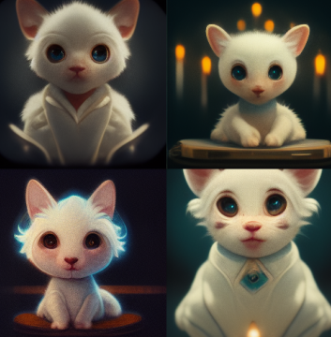

<https://i.mj.run/abba909e-744d-4fa3-b164-0b6d8a62e0ed/0_1.png> Medieval Fantasy Village, Gothic Architecture, steps, Riverside, Beautiful, Mystical, Lovely, water, fantasy, Picturesque, Threatening sky, Winter, intricate detail, detailed, Dramatic lighting, Chiaroscuro, Concept art, Digital art, Jordan Grimmer, Darek Zabrocki --ar 1:2

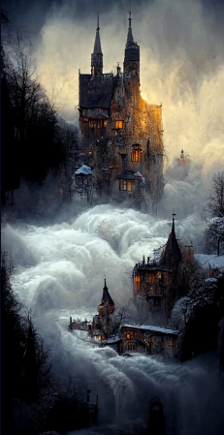

Baroque style , this is a beautiful illustration depicting a glowing butterfly fairy . fire Butterflies fel in love with ice at sea . Like a charming buterfly surrounded by roses , mysterious and beautiful , focus plane , blue background , unreal engine ,8K HD , HD --ar 9:16

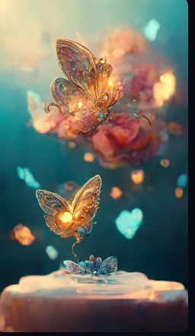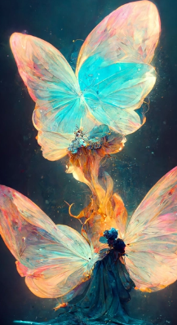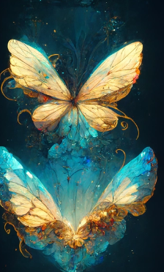

The purity of the sky, the deep purple of the Milky Way, was stunning. Depression, emptiness, lakes, reflections. 8K, Ultra wide Angle, panoramic, 3D, Ultra HD, High pixel, Marc Adamus HD Landscape Photography --ar 9:16

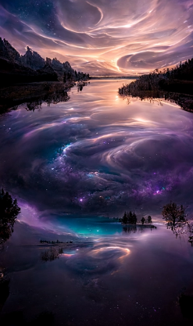

Highly detailed stunning image of a door with a special portal surrounded by flowers leading to another world, 3D render by Andrei Riabovitchev, Shaun Tan and Peter Mohrbacher Octane render. Hyper realistic. Soft illumination. artstation --ar 9:16

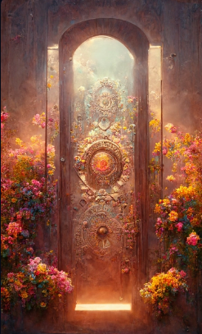

Golden, dreamlike sky, shocking, depressing, ethereal, lake, reflection, calm amber. Real, realistic, 8K, ultra wide Angle, panoramic, 3D, Ultra HD, high pixel, landscape photography Marc Adamus HD --ar 9:16

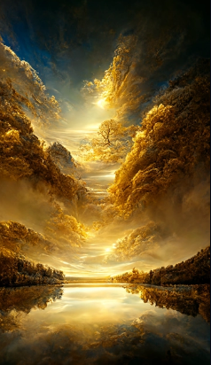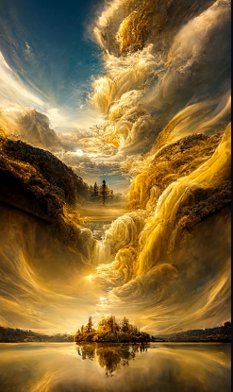

In a surreal CG rendering of ancient China, the Great Wall architecture is in a fairyland. At night, the stars are very bright, the smoke is very attractive, the maple leaves and milky white leaves are trees, snow scenery, HD --ar 9:16

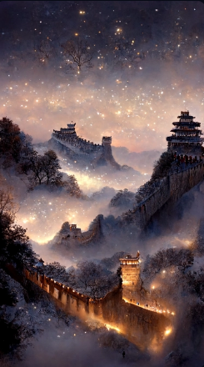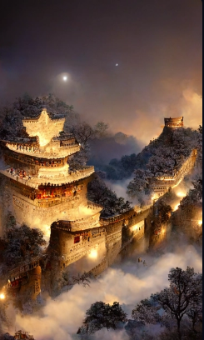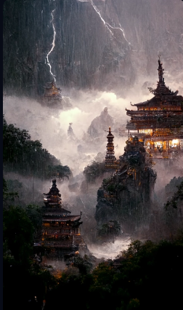

artstation landscape, a king and queen sword fighting, night, raining, heavy lightning and thunder, ancient asian temple in the mountain,extremely detailed, intricate, interlace, landscape, blue accent, Mythology, cinematic, detailed, atmospheric, backlit, epic , cinematic , concept art, matte painting --ar 9:16

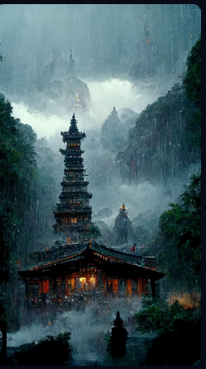

highly detailed wizard's cottage, a pheonix perched, hyperrealistic, light, fantasy, epic, magical, intricate, regal, flowers, sunrise, bright, swirly intricate linework background by stanley artgerm lau, greg rutkowski, octane render hyperrealistic thomas kinkade, alphonse mucha, loish, + 4k + uhd + 3d + octane render + cinematic, --ar 9:16 --upbeta

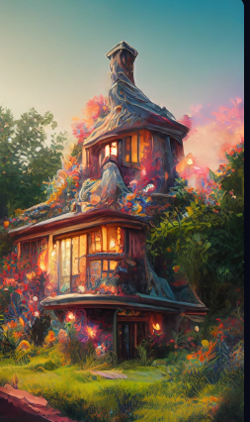

Pure sky , as red as fire , shocking . depressing , ethereal , lake , reflection .8k, ultra wide angle , panorama ,3D, Ultra HD , high pixel , landscape photography by Marc Adamus hD --ar 9:16

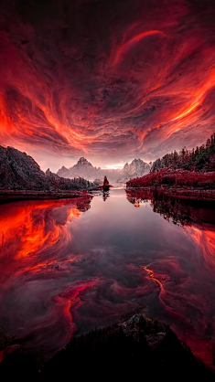

In the surreal CG rendering of ancient China, there is Yaolin fairyland beside the ancient architectural town in the south of the Yangtze River. At night, the stars are bright, the smoke is charming, the maple leaves and milky leaves are trees, the snow scene,hD --ar 9:16

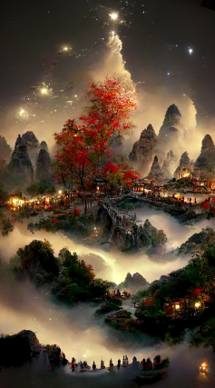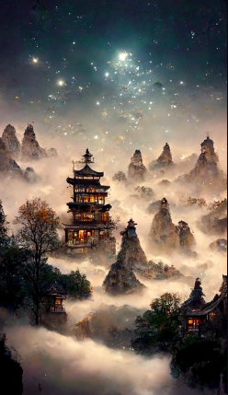

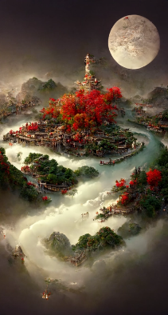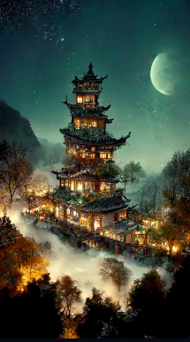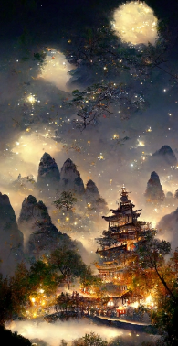

In the surreal CG rendering of ancient China, there is Yaolin fairyland beside the ancient architectural town in the south of the Yangtze River. At night, the stars are bright, the smoke is charming, the maple leaves and milky leaves are trees, the snow scene,hD --ar 9:16

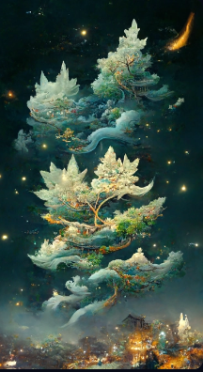

Light white jade pendant

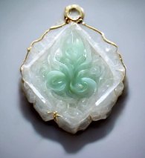

<https://i.mj.run/21ca73e1-0c28-4f3c-80b5-fe229a3786ea/0_0.png> a beautiful bright solarpunk landscape with hot steaming ponds, utopia, green vines, black monolith, trees and futuristic buildings covered in plants and flowers, solarpunk, by Albert Bierstadt and Thomas Cole and Paul Lehr --ar 3:2 --test --creative --upbeta

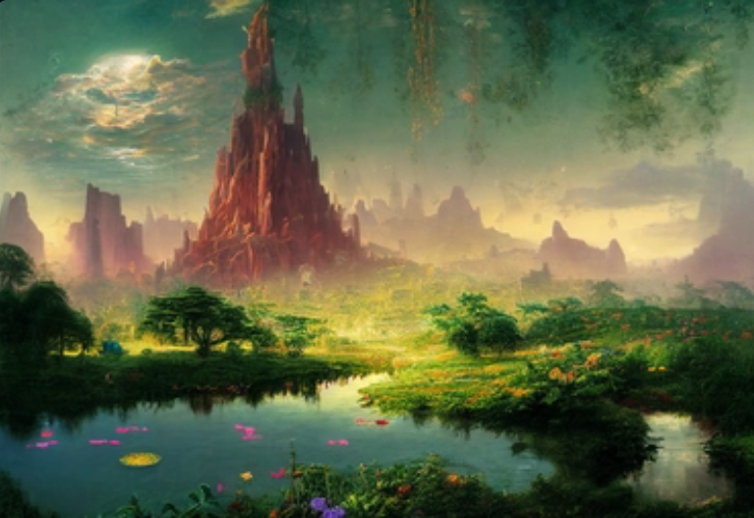

<https://i.mj.run/97972865-6901-4706-b834-3ea18658cd9c/0_0.png> a beautiful bright solarpunk landscape with hot steaming ponds, utopia, green vines, black monolith, trees and futuristic buildings covered in plants and flowers, solarpunk, by Albert Bierstadt and Thomas Cole and Paul Lehr --ar 3:2 --test --creative --upbeta

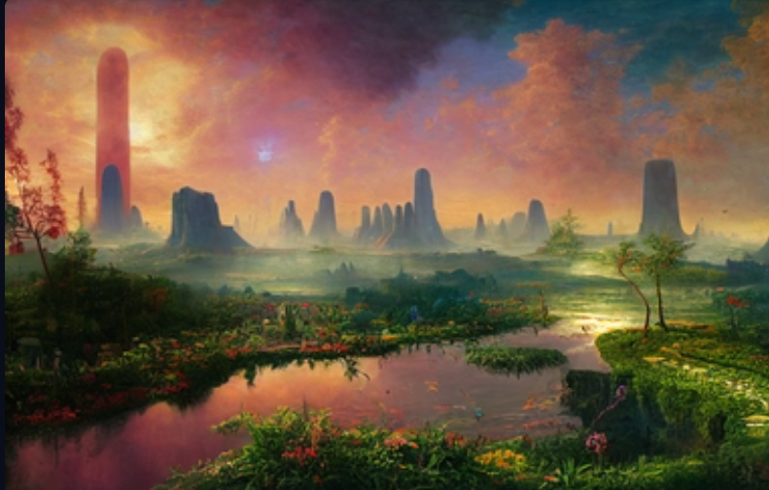

<https://i.mj.run/1982daff-be03-4c4b-b537-225b02cc8659/0_0.png> a beautiful bright solarpunk landscape with ponds, utopia, green vines, monolith, trees and futuristic buildings covered in plants and flowers, solarpunk, by Albert Bierstadt and Thomas Cole and Paul Lehr --test --creative --upbeta

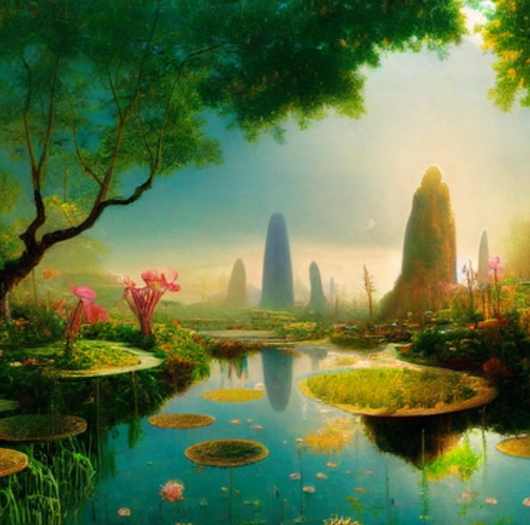

<https://s.mj.run/-kbLKuvSRuw> beautiful peaceful underground cave grotto library with pond, photorealistic, lush greenery, candles, white pink flowers, 8k, highly detailed, Octane Render, Unreal Engine --ar 3:7 --test --creative --upbeta

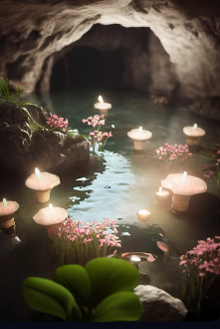

<https://i.mj.run/a1c4b1fb-d6a6-4d63-8031-2af277a3f563/0_0.png> picnic spread in beautiful New Zealand, gorgeous scenery, checkered picnic blanket, wicker picnic basket, delicious bread, cheese wheel, wine, flowers, romantic candles —ar 3:2 —testp --upbeta

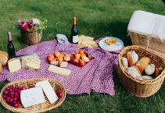

<https://i.mj.run/291f57ee-14ab-4b5b-833b-a1b954722dc8/0_0.png> picnic spread in beautiful New Zealand, gorgeous scenery, checkered picnic blanket, wicker picnic basket, delicious bread, cheese wheel, wine, flowers, romantic candles —ar 3:2 --test --creative --upbeta

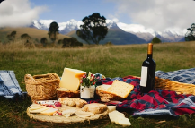

<https://s.mj.run/vNifS6oopUo> cute creature design, portrait of Ori from The Will of the Wisps, peaceful underground cave pond grotto, lush greenery, blue glowing moss, Octane Render, Unreal Engine --ar 2:3 --test --upbeta --upbeta

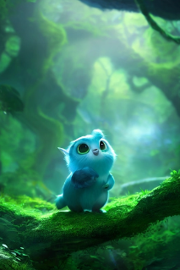

cute creature design, portrait of furry turquoise creature with long ears and bushy tail, huge cute eyes, cute bunny nose, standing on mossy log, lush forest greenery, glowing mushrooms --ar 2:3 --testp --upbeta

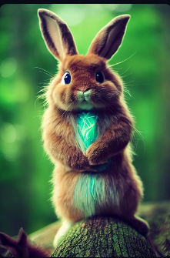

<https://s.mj.run/3zhAaVdMbpo> beautiful woman in peaceful underground cave grotto library with pond, plant vines, expensive pillows, library books, photorealistic, lush greenery, romantic candles, white red flowers, 8k, highly detailed, Octane Render, Unreal Engine --ar 3:2 --test --creative --upbeta

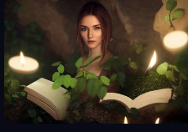

<https://s.mj.run/G4T2-4FFiX0> beautiful woman in peaceful underground cave grotto library with pond, plant vines, library books, photorealistic, lush greenery, romantic candles, white red flowers, 8k, highly detailed, Octane Render, Unreal Engine --ar 2:3 --testp --upbeta --upbeta

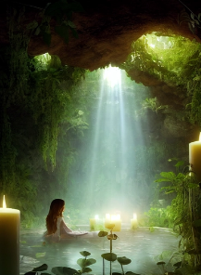

cute fantasy creature design, portrait of furry subtle turquoise creature with lynx ears and long bushy tail, huge cute eyes, cute nose, standing on mossy ground, lush forest greenery, glowing mushrooms all around, dramatic lighting, night --ar 2:3 --test --creative --upbeta

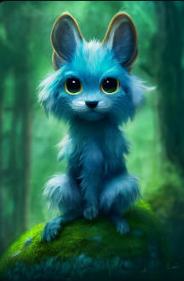

<https://s.mj.run/o6KjIJ2DnGs> beautiful peaceful underground cave grotto library with pond, photorealistic, lush greenery, candles, white pink flowers, 8k, highly detailed, Octane Render, Unreal Engine --ar 3:7 --test --creative --upbeta

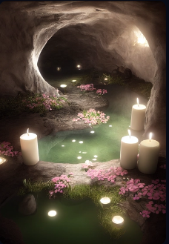

<https://s.mj.run/ugvIr4jbQRk> cute creature design, Ori from The Will of the Wisps, peaceful underground cave pond grotto, lush greenery, blue glowing moss, Octane Render, Unreal Engine --ar 2:3 --test --creative --upbeta

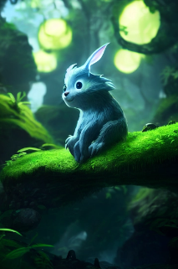

<https://s.mj.run/r3Se0b5VKGI> character design, Ultron reimagined as a medieval knight in intricate metallic armor --ar 2:3 --test --upbeta --upbeta

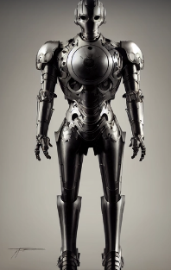

<https://s.mj.run/UgPPF4a4G4M> beautiful female sorceress full body, magical ancient wisteria, lunar eclipse, Octane Render, Unreal Engine, 8k, photorealistic, hyper realistic, ultra realistic --ar 3:7 --test --creative --upbeta

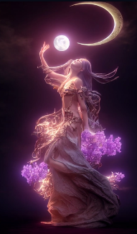

<https://s.mj.run/5NlNV9ylXqw> character design, Ultron reimagined as a medieval knight in intricate metallic armor, Unreal Engine, Octane Render --ar 2:3 --test --creative --upbeta

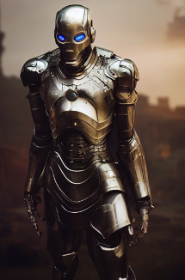

<https://s.mj.run/N3Ru0zzUWWs> character design, Ultron reimagined as a medieval knight in intricate metallic armor, Unreal Engine, Octane Render --ar 2:3 --test --creative --upbeta

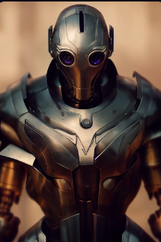

The Master Sword from The Legend of Zelda, intricate details, glowing, pedestal, Octane Render, Unreal Engine --ar 2:3 --test --upbeta

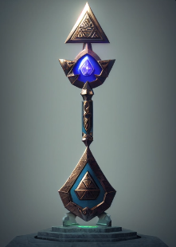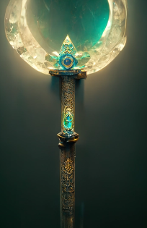

<https://s.mj.run/n3J-p1FmXaQ> character design, portrait of beautiful angel standing defiantly in front of the Ark of the Covenant treasure, cinematic lighting, Unreal Engine, Octane Render, photo realistic --ar 2:3 --test --creative --upbeta --upbeta

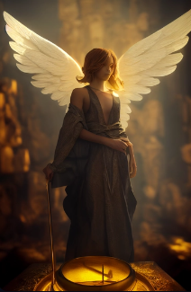

<https://s.mj.run/PTAcFrN1HwQ> character design, portrait of anthropomorphic wolf knight, detailed intricate metallic armor —ar 2:3 —test --upbeta

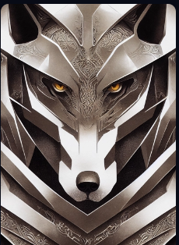

<https://s.mj.run/2pTfM7zt8SU> character design, portrait of anthropomorphic wolf knight, detailed intricate metallic armor —ar 2:3 —test --upbeta

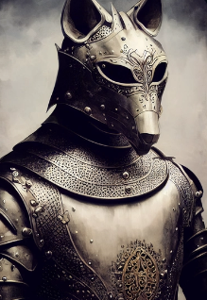

<https://s.mj.run/X9GCMjt0YH4> rose frozen in ice, highly detailed, octane render, unreal engine --test --creative --upbeta

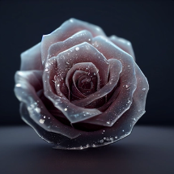

<https://i.mj.run/64719314-7bfc-4283-b8fe-e4e02cf7a046/0_0.png> Tiny cute adorable fluffy cat with knitted blue scarf leaning at a table in a medieval pub holding a coffee cup, anthropomorphic, Jean-Baptiste Monge, soft cinematic lighting, 8k, intricate details, portrait, Pixar style character, old fashioned movie style --test --creative --upbeta



<https://i.mj.run/c58f8268-c274-471d-b70d-3df1e94e54cd/0_0.png> nebula in outer space. nebula shaped like a human skull, photorealistic, deep blacks, low noise, hubble, 8k, --s 5000 --ar 2:3 --upbeta --testp --upbeta --upbeta

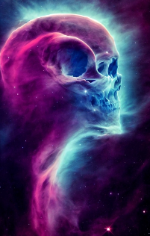

<https://i.mj.run/f0fca1d8-ebf5-434e-b4d9-fedeb73c6551/0_0.png> fantasy house on mountain cliff, Simon Stalenhag, intricate detail, concept art, octane render, 8k, --ar 2:3 --testp --creative --upbeta

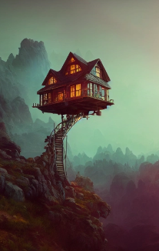

<https://i.mj.run/897da4f9-a4fe-44aa-b5d6-3bbd61d5f218/0_0.png> a glass bottle on its side containing a translucent blue nebula Sea + Majestic Pirate Ship, ethereal, Cinematic, backlit, eerie Trending on Artstation, ultra detailed, matte painting, photo, arnold renderer --test --creative --upbeta



<https://i.mj.run/03e45a4c-a701-43a6-9be3-f19cecb6f178/0_0.png> character design, Pixar style, tiny cute and adorable lama, shades of blue, anthropomorphic, dramatic lighting, cinematic, portrait, fine details, zoomed in, 150mm + 8k + UHD + photorealistic + HDR + FStop 1.8 + High octane render + Unreal engine 5 + cinematic + highly detailed + ray tracing + sharp focus --test --creative --upbeta

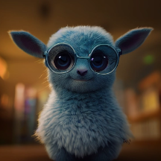

<https://i.mj.run/af47d385-f483-40ae-a1c6-eb3ee818f86c/0_0.png> muscular young woman wearing a tank top and hotpants and ankle socks with very short brown hair and green eyes, full body, feminine features, canon 8k, hdr10, --test --ar 2:3 --upbeta

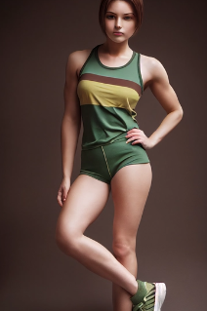

<https://i.mj.run/ca65390f-7e81-4397-8a1a-0cc10cd0e91b/0_3.png> butterfly made of blue stars, butterfly made of constellations, black background, butterfly blue stars, blue constellation butterfly, hyper realistic, ultra detailed, photography, photorealistic, intricate detail, 4k resolution

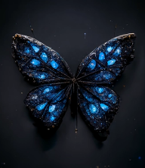

<https://i.mj.run/1e81b665-c5e7-49fd-a259-d5e693df6f6f/0_0.png> woodland oracle, anthropomorphic stop motion rabbit wearing long flowing robes, serene face, haunted woods, Wes Anderson, mystical, dreamy lighting, god rays --test --upbeta --upbeta

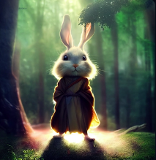

<https://i.mj.run/8c65e431-c62d-4e8e-98f8-cc4e6fdd40bf/0_0.png> An anthro cat woman, big ears, wearing armor and a cloak, gauntlets, cartoon, traditional art, zootopia, cgi, cute, spunky, cartoon style, anime style, stylized, steel boots, 4k, 8k, octane render, sharp, accurate, full body, full render, full shot, action pose, cute lighting, uhd, cinematic lighting, soft --test --ar 9:16 --seed 7407 --upbeta --v 3 --upbeta

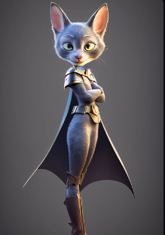

Young Arnold Schwarzenegger body Conan the Barbarian fighting large orcs, Cinematic, epic scene, Photography, Shot on 70mm, Telephoto, F/2.8, high Contrast, 8K, Cinematic Lighting, Volumetric Lighting, etheral light, intricate details, extremely detailed --ar 1:2 --testp --upbeta --upbeta

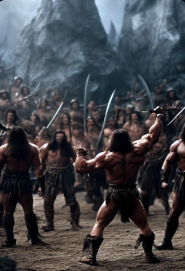

МЦД futuristic train closeup moscow --testp --upbeta --upbeta

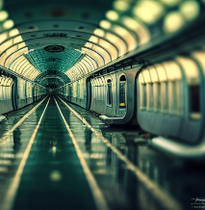

dnd Genie in a bottle, unreal engine, ultra realistic, photorealistic, octane render, 8k, 4k

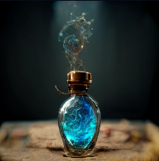

<https://i.mj.run/fdcf76f2-323d-4017-8f81-3cdd26db7342/0_0.png> Shimmering white diamond trapped inside glass stone, rutiliated inclusions crystalpunk

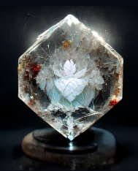

<https://i.mj.run/404dc1f0-8cb7-4bd8-8606-7ac21b43331c/0_0.png> an illegal drug named "Shattered," decadent opium dens taken by heart shattered losers, gloomy and sad atmosphere, luxurious but old-fashioned interiors, epic but hopeless people, cinematic photo compositions, volumetric lighting, photorealistic and Intricate detail —ar 2:3 --test --creative --upbeta

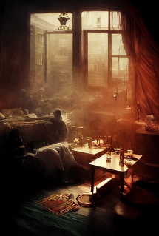

cozy witch's cottage by an ethereal lake, prismatic, dreamy, surreal, mysterious, wiccan, vivid colors, octane render, unreal engine, 8k, realistic --ar 2:3 --test --creative --upbeta --upbeta

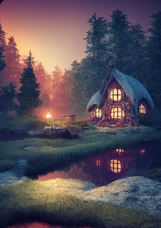

<https://i.mj.run/474f2486-1d5f-4093-8e22-865830299801/0_0.png> Fantasy flying ship by Makoto Shinkai. 5D, Studio Lighting, insanely detailed and intricate, hypermaximalist, elegant, ornate, super detailed --ar 3:2 --upbeta --test --upbeta --upbeta --v 3 --upbeta --upbeta

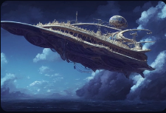

flowerpunk sugar candy sweets, for Space Dandy, Ghost in the Shell, glitched in Unreal Octane 6 --ar 2:5

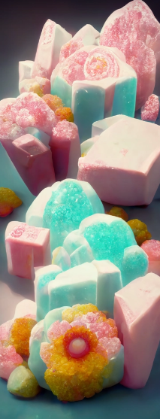

<https://i.mj.run/f5265744-3702-4293-b097-adf487a45445/0_0.png> elvish castle city bones necromantic , dark fantasy, fantastic, far away, epic mythical atmosphere, sof lighting, light rays, cinematic lighting --ar 2:3 --test --creative --upbeta

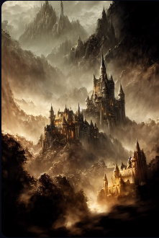

<https://i.mj.run/6aede2c0-6507-46d3-bd40-c314d735944b/0_0.png> a narrow cave opening in a rock formation --test --creative --upbeta

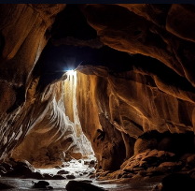

anthropomorphic cute light yellow female fox, large tail, long black hair, black bangs, kimono top, pretty, beautiful, cartoon, traditional art, zootopia, cgi, cute, spunky, cartoon style, anime style, stylized, 4k, 8k, octane render, sharp, accurate, full body, full render, full shot, action pose, cute lighting, uhd, cinematic lighting, soft --testp --ar 9:16 --upbeta

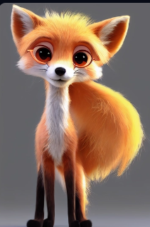

<https://i.mj.run/7abac322-132a-4577-b037-bf32ad061454/0_0.png> tiny cute adorable orange cat dressed as a doctor, tweed victorian tailcoat, anthropomorphic, Jean-Baptiste Monge, soft cinematic lighting, 8k, intricate details, portrait, Pixar style character --test --creative --upbeta --upbeta



<https://i.mj.run/f42c4a47-7b5f-4978-9018-6c5b2f2e8c5e/0_0.png> warlock cat female Tabaxi, sinister look with glowing eyes, black fur, in dnd character art style, cold lighting scheme, by Hyung-tae Kim and Krenz Cushart and artgerm on artstation --ar 9:16 --test --creative --upbeta --upbeta

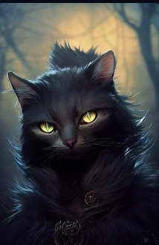

<https://i.mj.run/af9ba0b6-4e5f-4728-b2c7-3eb08a6b8b9c/0_0.png> baby seal plush wearing a crown, hopeful animated eyes , center of screen, unreal engine, lightly detailed, backlit, dimensional, shallow depth of field --test --creative --upbeta --upbeta --upbeta

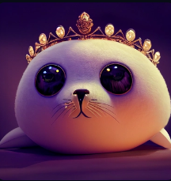

<https://i.mj.run/9fe10bf5-7118-41ed-b393-0a93cff86c0f/0_0.png> a steamy alluring Portrait photo of the White Queen in tights, behance contest winner, ultra-detailed, high end finish, octane render, cinematic lighting, high contrast, 8k, photo realistic, character design, uhd, 4k --test --upbeta --upbeta

样图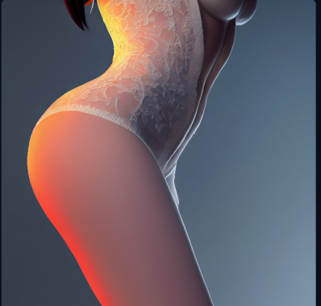

测试

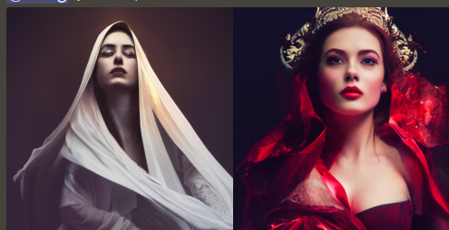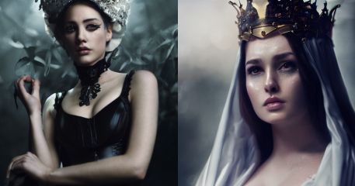

Portrait of a beautiful, curvaceous, Pirate princess goddess babe, red hair, intricate ornate costume, Caribbean background + outdoors + Ocean, painted by ArtGerm, Alphonse Mucha, Roberto Ferri, Ross Tran, Pixar, low angle shot, digital painting, cinematic rim lighting, Unreal Engine 5, 8K --ar 2:3 --test --creative --upbeta --no watermark --upbeta --upbeta --upbeta -

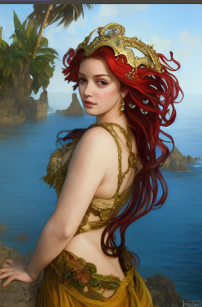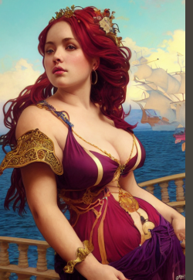

baby bunny jumping into the air, cute, happy, canon r5, —testp --upbeta

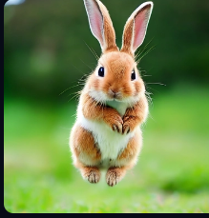

a tiny fox in a forest, big eyes, Peach blossom,stream,enchanting,immortal,fluffy, shiny mane,Petals,fairyism,unreal engine 5 and Octane Render --testp --ar 9:16 --upbeta --upbeta

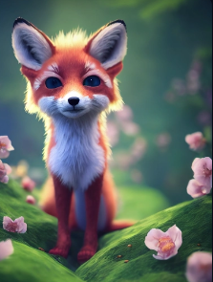

black haired christina hendricks, porcelain skin, style of my hero acadamia, very large beautiful detailed blue anime eyes, doe eyes, artgerm, full figure, passionate, alluring, pastel curtain background, pencil illustration --ar 2:3 --upbeta --s 1250 --test --upbeta

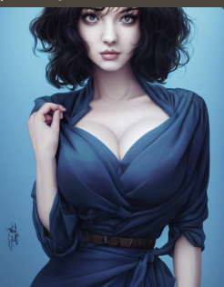

full shot the shattered hearts queen orbiting earth looking for a heart to mend , big earth with galaxy background , soft mist, cinematic, sun rays, dappled shade, bioluminescence, photorealistic, concept art, intricate detailed,3D character design ,8K, --ar 12:16 --test --creative --upbeta --upbeta

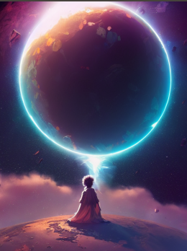

<https://i.mj.run/80f2e7d4-5d12-468f-95e4-83e213f5aa7b/0_0.png> An anthro ferret woman, big ears, wearing armor and a cloak, gauntlets, cartoon, traditional art, zootopia, cgi, cute, spunky, cartoon style, anime style, stylized, steel boots, 4k, 8k, octane render, sharp, accurate, full body, full render, full shot, action pose, cute lighting, uhd, cinematic lighting, soft --test --ar 9:16 --upbeta --upbeta --v 3 --upbeta

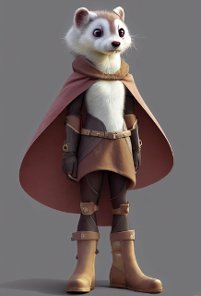

<https://i.mj.run/e186b166-68ae-4dc0-af15-e99a8a73e33a/0_0.png> Lightning storm inside a glass bottle, Canon EOS 5D Mark III, 85mm lens, HD, 8k, Ultra Realistic, Hyper Realistic, volumetric lighting, 4K, unreal engine, octane render, electric arc, 1 ultraviolet, 1 violet, 1 --ar 9:16 --no hood, hat --test --creative --upbeta

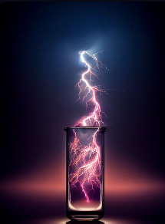

<https://i.mj.run/d4cec261-3c52-4031-a58a-ee0560809960/0_0.png> champagne supernova in the sky, 12mm, f2.8, unreal engine, ethereal, magical, mystical --ar 9:21 --test --creative --upbeta

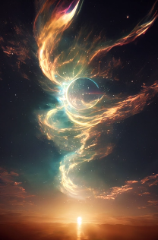

medium shot of a cute mi'qote girl from final fantasy 14, portrait, perfect large detailed doe eyes, alluring, beautiful, one face, amazing cinematic lighting, unreal engine 5 render, 8k octane render, Artwork by Norman Rockwell, Artgerm, style of Final Fantasy, League of Legends --ar 4:5 --test --creative --upbeta



2 Twisted Neutron stars, giant galaxy, colorful, 4k

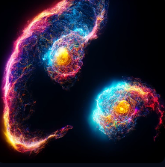

A cute and adorable baby white panda pink a big fluffy tail,holding a pink flower lay on a cloud in paradise,big eyes,Peach blossom,stream,enchanting,immortal,fluffy,shiny mane,Petals,fairyism,unreal engine 5 and Octane Render --testp --ar 9:16 --upbeta

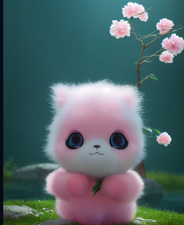

adorable and cute panda, Miyazaki Hayao style, highly detailed, artwork, 8k



<https://i.mj.run/8f3758bb-a1fa-4bb0-a1b1-fd944c8670e9/0_0.png> photorealistic cute adorable rare kitten breed wearing white and blue samurai armor, 2.5 the itinerary is written on ornate medieval paper, 2 frozen ice paws, blue katana, magical atmosphere, 2 unreal engine, dramatic lighting, photorealism, photorealistic, cinematic lighting, volumetric lighting --test --creative --upbeta

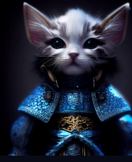

gorgeous anthropomorphic monkey wearing leather assassin armor, intricate pattern, ornate epic design, cinematic lighting, lush ornate forest background, sharp focus, volumetric, rendered in pixarian armor character engine, photorealistic --ar 9:16 --testp —s 1250 —video --upbeta --upbeta --upbeta

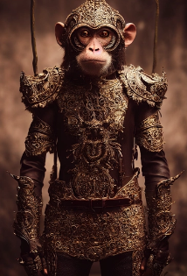

<https://i.mj.run/fd976d77-d931-44f9-8e57-22d5fd182039/0_0.png> character concept, cute adorable rare kitten breed, wearing white and blue samurai armor, with ice paws detailed, blue and gold details, ultra-detailed, photorealism, photorealistic, cinematic lighting, volumetric lighting, 32K --ar 9:16 --upbeta --test --creative —chaos 50 --upbeta



character concept, cute adorable kitten breed wearing blue and gold samurai armor, frozen ice paws, detailed, ultra detailed, photorealism, photorealistic, cinematic lighting, volumetric lighting, 32K --ar 9:16 --upbeta --test --creative —chaos 50 --upbeta

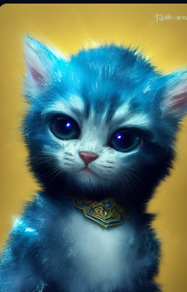

<https://i.mj.run/1afe4b73-862b-480f-949e-1cca9bdec3f5/0_0.png> Marvel's black panther, Portrait, Finely detailed intricate filigree golden armor, Cinematic lighting, Volumetric lighting, Epic composition, Photorealism, Bokeh blur, Very high detail, Sony Alpha α7, ISO1900, Character design, Unreal Engine, Octane render, HDR, Subsurface scattering, --aspect 9:32 --testp --upbeta --upbeta



cute alien carnage symbiote, bunny, alien bunny, unreal engine --test --upbeta

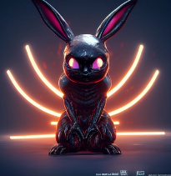

<https://i.mj.run/489bc37c-65f0-451d-9236-713b73a34176/0_0.png> cute hot beautiful gorgeous anthropomorphic tiger cheetah lemur, wearing cybernetic assassin exosuit, 2 intricate pattern, ornate epic design, cinematic lighting, ultra-detailed, Lenticular impressionistic background, sharp focus, volumetric, rendered in zoids anime engine, photorealistic --ar 9:16 —video --test --creative --upbeta

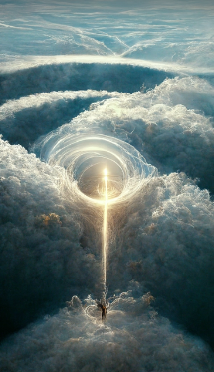

Tiny cute adorable fluffy tiger with knitted blue scarf leaning at a table in a medieval pub holding a coffee cup, anthropomorphic, Jean-Baptiste Monge, soft cinematic lighting, 8k, intricate details, portrait, Pixar style character, old fashioned movie style —ar 9:16 --testp --upbeta --upbeta



Rerolling prompt Pixar Style, Tiny cute floppy ear tiger adventurer dressed in fantasy armour , jean - baptiste monge , anthropomorphic , dramatic lighting, 8k, portrait --ar 9:16 --test --upbeta --upbeta

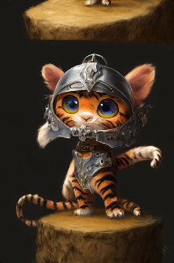

cute fantasy baby cattle dressed in Chinese Hanfu, full body, extremely detailed 3D animation, symmetrical centred, peach blossom background, colourful octane render, pixar style --ar 9:16 --testp --s 5000 --upbeta --upbeta --upbeta

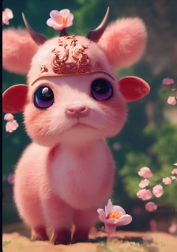

Rerolling prompt Pixar Style, Tiny cute floppy ear cattle adventurer dressed in fantasy armour , jean - baptiste monge , anthropomorphic , dramatic lighting, 8k, portrait --ar 9:16 --test --upbeta --upbeta

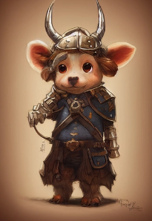

Character design, Pixar style, cute little cattle, golden ratio, fine details, dramatic lighting, movies, portraits, --testp --upbeta --ar 8:16 --upbeta

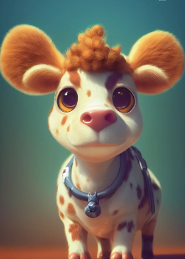

Anthropomorphic majestic cattle knight, portrait, finely detailed armor, cinematic lighting, intricate filigree metal design, 4k, 8k, unreal engine, octane render, --ar 9:16 --testp --upbeta --upbeta

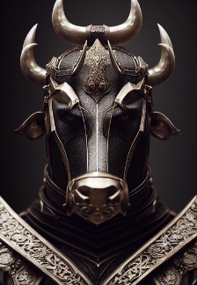

<https://i.mj.run/6474b46b-ab76-4872-8101-9c9cf1c5523c/0_0.png> anthropomorphic, Tiny cute and adorable rabbit , dressed Chinese Hanfu outfit with Osmanthus fragrans background, petals falling, in the style of Pixar , photorealistic, octane render 8k, hyper detail, colorful,hd --ar 9:16 --testp --s 5000 --upbeta



cute fantasy rabbit, full body, big eyes, extremely detailed 3D animation, symmetrical centred, peach blossoms background, colourful octane render, pixar style --ar 9:16 --testp --s 5000 --upbeta

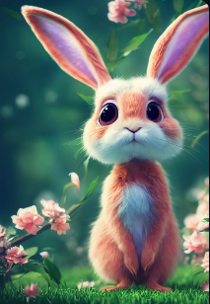

anthropomorphic, Tiny cute and adorable rabbit , dressed Chinese Hanfu with Osmanthus fragrans background, petals falling, in the style of Pixar , photorealistic, octane render 8k, hyper detail, colorful,hd --ar 9:16 --test --s 5000 --upbeta

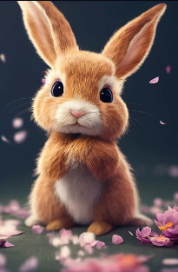

<https://i.mj.run/2361d99e-6ba6-4287-a3bd-b1b32595c95e/0_0.png> cute fantasy cattle, full body, extremely detailed 3D animation, symmetrical centred, peach blossoms background, colourful octane render, pixar style --ar 9:16 --test --creative --s 5000 --upbeta

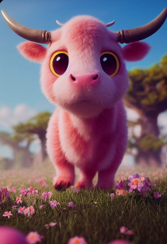

cute fantasy cattle, full body, extremely detailed 3D animation, symmetrical centred, peach blossoms tree background, colourful octane render, pixar style --ar 9:16 --test --s 5000 --upbeta

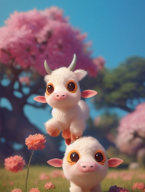

cute fantasy cattle, full body, extremely detailed 3D animation, symmetrical centred, peach blossoms tree background, colourful octane render, pixar style --ar 9:16 --test --creative --s 5000 --upbeta

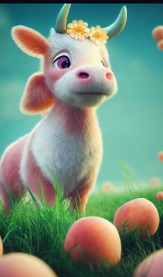

eautiful temple,at noon, cyan and white temple in the clouds, light blue sky，cyan and pink clouds,rose garden，artstation,by Eliseo H.Zubiri and lan Fisher，cgsociety，vary，Maxwell，ultrawide shot，cgsociety，vary，Maxwell，ultrawide shot，8k,photorealistic --ar 9:16 --stop 90 --s 5000 --uplight

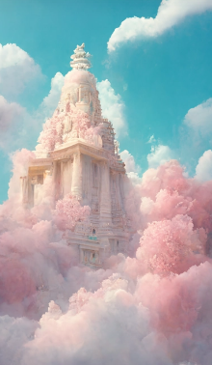

Magic palace,Sakura Island,paradise,white,pink,luminous water,Sakura,magic,realism,redshift rendering,3D,super detail,lifelike,8K,masterpiece,functional art station,top view,panorama,super wide angle, photorealistic --ar 9:16 --s 5000 --uplight

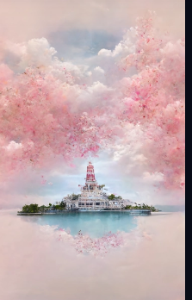

Magic palace,Sakura Island,paradise,white,pink,luminous water,Sakura,magic,realism,redshift rendering,3D,super detail,lifelike,8K,masterpiece,functional art station,top view,panorama,super wide angle, photorealistic --ar 9:16 --s 5000 --upbeta

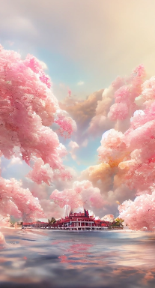

rendered by high-definition CG, cloud,golden Chinese palace, flame, HD, 4K,HD --ar 9:16 --s 5000

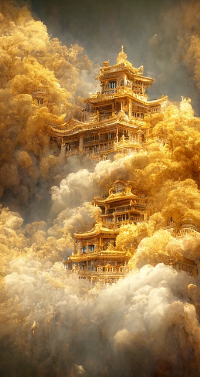

<https://i.mj.run/6ae87e0d-bc9b-48fb-b51d-2e442eb8dff2/0_2.png> rendered by high-definition CG,Phoenix, cloud,golden Chinese palace, flame, HD, 4K,HD --ar 9:16 --s 5000

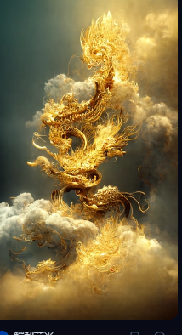

A fantasy world, a nebula-like magic is flowing everywhere while the inhabitants wander the floating streets, 8k, details, colored pencil,hd --ar 9:16 --s 5000

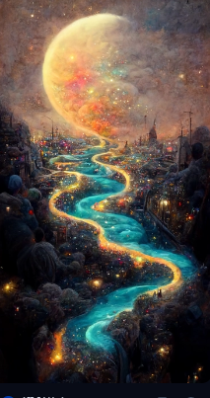

The background is the starry sky painted by Van Gogh, the starry sky painted by Van Gogh,Makoto Shikai,ray tracing, ambient occlusion, intricate details, reflections, vivid colors ,hd --ar 9:16 --s 5000

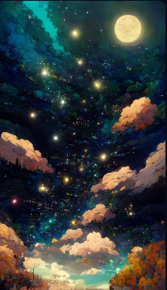

The Little Prince on a small planet, space, alone, stars ,Gran blue fantasy + FGO + animation style. Clear color,hd --ar 9:16 --s 5000

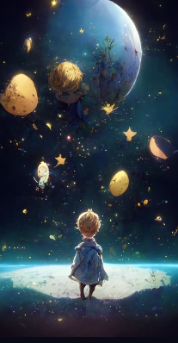

A beautiful painting of a vast empty desert dunes at night, with a single mystical giant glowing blue tree at the middle, the tree's blue glow illuminates its surroundings, stars in the sky, by ted nasmith and thomas kinkade, 8k,featured on Artstation --ar 9:16 --s 5000

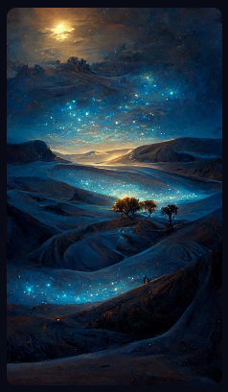

A picture of mouse,it is curved golden, there are many shining petals, petals are golden, gold petals flying, fog, background is golden, golden, fluorescent, dream, brilliant, unreal engine, art station, super wide Angle, top panorama, hd --ar 9:16 --s 5000

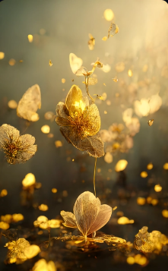

Cotton candy house, fairy tale art style, volume lighting, high detail, unreal, 3D rendering.，HD. --ar 9:16

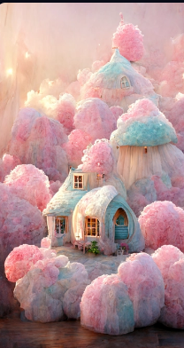

A fantasy world, a nebula-like magic is flowing everywhere while the inhabitants wander the floating streets, 8k, details, realistic，Gran blue fantasy + FGO + animation style. Clear color ，hd --ar 9:16

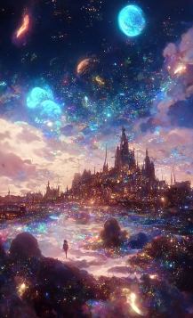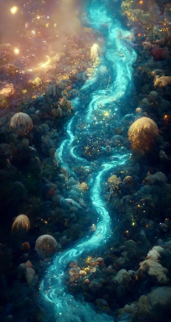

magic lotus, gold::1, white::1, glowing, Artstation and artgerm+color trends by Greg Rutkowski and James Gurney, cinematic lighting, dreamy, lots of details, 8k, --ar 19:16



Chinese mountains and rivers, ink wash, atmospheric, magnificent, black::1, white::1, glowing, Artstation and artgerm+color trends by Greg Rutkowski and James Gurney, cinematic lighting, dreamy, lots of details, 8k

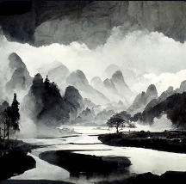

<https://s.mj.run/oX7phtWK9u0> Cute-Kitty, Cyberpunk, glow, Artstation and art + color trends by Greg Rutkowski and James Gurney, cinematic lighting, dreamy, lots of details, 8k

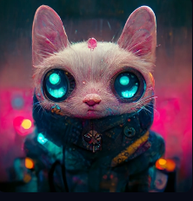

<https://s.mj.run/x90EZgYYSYE> wedding dress, blue, gorgeous, mucha, --ar 11:16

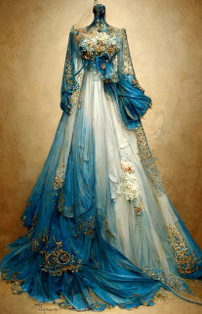

<https://s.mj.run/7mSFhOn3O2s> Interior view of greenhouse with butterfly glass windows, symmetrical composition, pale pink::1, white::1, glowing, Artstation and artgerm+color trends by Greg Rutkowski and James Gurney, cinematic lighting, dreamy, lots of details, 8k, --ar 11:16

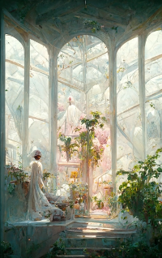

Lake in the Forest, Symmetrical Composition, Sunlight, Blue::1, White::1, Glow, Artstation and artgerm+ Color Trends by Greg Rutkowski and James Gurney, Cinematic Lighting, Fantasy, Lots of Detail, 8k,

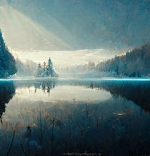

<https://s.mj.run/_pyQb9gs8Do> Cyberpunk bedroom interior with large windows with urban skyline,glowing, Artstation and artgerm+color trends by Greg Rutkowski and James Gurney, cinematic lighting, dreamy, lots of details, 8k

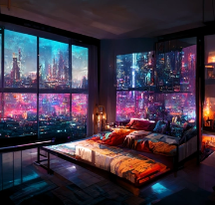

Small cabin on the grassland, sunset, warm, soft,glowing, Artstation and artgerm+color trends by Greg Rutkowski and James Gurney, cinematic lighting, dreamy, lots of details, 8k, --ar 9:16

